The Parent’s Guide to the Creative Curriculum®

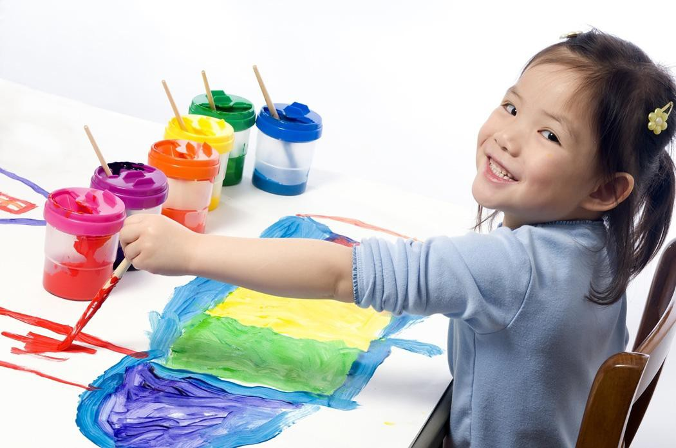

For Preschoolers

Table of Contents
How to Use this Guide 3
Literacy 3
Dramatic Play 6
Block Play 7
Manipulative Play/Toys & Games 8
Art 10
Sensory 11
Library 13
Music & Movement 15
Cooking 16
Outdoors/Gym 18
Discovery/Science 19

How to Use this Guide
This guide is designed to help families understand what the Creative Curriculum is and how it is implemented at the Child Care and Learning Center. We have broken down each of the ten interest areas with a description, an explanation of what your child(ren) learns in each area and a home/school connection piece.

Literacy
Becoming literate doesn’t just happen. Our teachers thoughtfully and purposely interact with children and plan experiences that support emerging literacy. A print-rich environment that allows children to practice literacy skills in real-life experiences, combined with explicit teaching of key concepts, is the foundation of literacy learning in preschool. As children’s excitement about their newfound ability to read and write increases, our teachers create multiple opportunities for continued literacy learning.
Recent studies have shown that there are seven components of literacy for preschool children ages 3-5:

- Increased vocabulary and language

- Phonological awareness

- Knowledge of print

- Letters and words

- Comprehension

- Understanding books and other texts

- Literacy as a source of enjoyment

Increased Vocabulary and Language

When children are exposed to rich vocabulary, they learn the words they will need to read and write. Research has shown that children who have large vocabularies and lots of experience using language are more successful in school. In our classrooms, the Creative Curriculum provides many opportunities for children to develop vocabulary and language.
These include
- informal conversations—talking with peers and adults throughout the day
- songs, rhymes, fingerplays, or movement activities
- firsthand experiences—hearing new words to describe what they are doing
- read aloud—listening to books and talking about new words in the story

Phonological Awareness

Phonological awareness is hearing and understanding the different sounds of spoken language. It includes the different ways oral language can be broken down into individual parts, separate sounds, and syllables.

Phonological awareness includes skills such as playing with rhymes, noticing how words begin with the same sounds, or clapping out individual words or syllables of a song, rhyme, or chant.

Phonemic awareness is the ability to hear, identify, and manipulate individual sounds—phonemes—in spoken words. Phonemic awareness is typically addressed in kindergarten and first grade.

It is common to confuse phonological awareness with phonics, but they are not the same. Phonics is connecting a printed symbol with a sound. Once children have grasped the concept that speech is made up of a sequence of sounds, the teacher can teach phonics.

Knowledge of Print
This component of literacy involves connecting print with meaning. Children acquire a knowledge of print by seeing it in the environment and

using it in their play. Children in our program will develop the following knowledge of print concepts:

- Print carries a message.
- Each spoken word can be written down and read.
- Print follows conventions (left to right, capital/lowercase letters, punctuation).
- Books have common characteristics (front, back, author, illustrator).

Letters and Words
This component of literacy is more than being able to recite the ABC song. Really knowing about letters involves understanding that a letter is a symbol representing one or more of the sounds in the English language; that these symbols can be grouped together to form words; and that these words have meaning.

Comprehension
Comprehension is understanding the meaning of spoken and written languages. Children with comprehension skills may ask questions or make comments on the topic of a story the teachers are reading, or they may act it out in their play.

Our teachers focus on the way they read to the children to promote and develop comprehension skills.

Understanding Books and Other Texts
Understanding books and other texts involves knowing how to read and write signs, menus, letters, shopping lists, newspapers, invitations, messages, journals, and books.

Books take many forms- narrative story books, predictable books, informational books, number books, alphabet books and poetry books. Our teachers help children learn about different forms of literature by making sure there are a variety of books in the classroom.

In addition to the classroom libraries, we have a school library for teachers to use in relation to the themes and topics the children are studying throughout the school year. We offer a wide selection of books from non- fiction sight word readers to fictional picture books.

We believe that literacy plays an important role in your child’s success as a lifelong learner, both in the classroom and out.

Literacy as a Source of Enjoyment
Motivation is also an aspect of literacy and one that is particularly important. Children read because they are motivated to learn something new that interests them, uncover the plot of the story, or discover something that makes them laugh. The more they read the better readers they become and the more motivated they are.

The 10 Interest Areas

Dramatic Play
Dramatic play is central to children’s healthy development and learning during the preschool years. For this reason, every classroom at CCLC includes an area designed to inspire creative and imaginative play. In the dramatic play area children break through the restrictions of reality. They pretend to be someone or something different from themselves and make up situations and actions that go along with the role they choose. When children engage in dramatic play, they deepen their understanding of the world and develop skills that will serve them throughout their lives. The ability to pretend is very important to your child’s development. Children who know how to make believe develop a good vocabulary, important for reading. They learn to cooperate with others and solve problems and are able to think abstractly, all important skills for success in school. When your child engages in pretend play we might ask “Is your baby sick?” “What are you going to do?”, or “What are you cooking for dinner tonight, it smells so good?” We talk with the children and participate in their play to extend their thinking.

What you can do at home…You can encourage the same kind of pretend play at home simply by playing with your child and providing some simple props. For example, a large empty cardboard box can become almost anything- a pirate ship, a castle, or a train. The nice thing about dramatic play is that it requires only your imagination!

What Your Child is Learning in the Dramatic Play Area:

- Use oral language in a variety of situations

- Learn social skills appropriate to group behavior

- Explore different celebrations and customs

- Practice self-help skills

- Participate in leadership/followship roles

- Work cooperatively

- Discover socially acceptable and unacceptable behavior

- Match pairs, sort and classify objects

- Make decisions

Blocks
The block area is one of the most valuable learning materials we have. When children build with blocks they learn math concepts, such as the number of blocks that fill a certain space. They compare the height of their buildings and learn geometric shapes. When they lift, stack, and move blocks, they explore weight and size. Each time children use blocks they are making decisions about how to build a structure or solve a construction problem. Children often use blocks to recreate the world around them by making a road or a house. They learn to work together and to cooperate. We encourage children to talk about what they are doing, to promote language development. We also talk with children and ask questions to

expand on their block play. For example, we might say, “I see you built a tall apartment house, how do the people get to their floor?” Questions like these make children more aware of what they are doing and encourage them to try out new ideas.

What you can do at home…You can encourage your child to learn through block play by taking an interest in what he or she does at our program. You can make/purchase your own blocks to play with at home. When you are on walks or away from home, make sure to point out interesting roads and buildings. When your child is playing with the blocks, be sure to talk about the things you saw outside of the house.

What Your Child Learns in the Block Area:

- Use vocabulary to compare objects

- Create, repeat, or extend patterns

- Develop hand/eye coordination

- Learn size and shape differentiation

- Understand gravity, stability, weight, and balance

- Think, create, and implement plans

- Develop respect for the work of others

Manipulative/Toys & Games
The manipulative area includes puzzles, various table blocks, small construction materials, such as Duplo/Legos, board games and collections of objects (including shells, bottle caps and buttons). When your child manipulates, they explore how things work; learn to be creative and use their imaginations; strengthen and control the small muscles in their hands; work cooperatively and solve problems; and learn math ideas and concepts.

When children are in the manipulative area, we encourage them to talk about what they are doing. For example, we might say “Tell me about the design you made” or “How did you get those rings to fit together?” These questions and comments are designed to help children develop their thinking skills.

What you can do at home…You play an important role in selecting toys and games that are safe, interesting, and appropriate for your child’s abilities. More importantly, research shows that the most creative children are those that have had adults in their play. Here are a few ways that you can be involved in your child’s play:

- OBSERVE. Watch as your child plays and notice their abilities and interests.

- PLAY. Follow your child’s lead and join in their play.

- IMAGINE. Keep in mind that there is more than one way to play with a toy. Be creative!

- ENJOY. Have fun being together, talking and playing.

What Your Child Learns in the Manipulative Area:

- Use vocabulary to define quantities and relationships.

- Form groups by sorting and matching.

- Repeat a simple pattern using objects.

- Develop fine motor skills.

- Develop perceptual awareness skills.

- Experience counting objects.

- Make predictions and explain why.

- Discover color, shape, line, and texture.

- Explore time units.

- Acquire eye hand coordination.

Art
Art is an important part of our curriculum. Everyday children find a variety of art materials available on our shelves. Drawing, painting, pasting, molding, and constructing are not only enjoyable, but also provide important opportunities for learning.

Children express original ideas and feelings, improve their coordination, learn to recognize colors and textures, and develop creativity and pride in their accomplishments by exploring and using art materials.

When children are engaged in art activities, we talk with them about what they are doing and ask questions that encourage them to think about their ideas and express feelings. We are just as interested in the creative process as we are in what children make. We say things that will encourage children to be creative and confident such as, “Tell me about your picture” instead of, “Is that a house you made?”

What you can do at home…Art is a very easy way to bring your child’s school life into your home. Children love to bring home their art products to share with you. Take time to talk with your child by saying things like, “Tell me about your picture” and “What do you like best about it?” Art is something your child can do at home in almost any room. You might designate a space for various materials including crayons, paper, scissors, glue, and collage materials. A child’s mind is much more creative and artistic than any coloring book allows.

What Your Child Learns in the Art Area:

- Discover line, color, shape, and texture by seeing and feeling objects.

- Express individual thoughts and feelings.

- Engage in conversation by sharing ideas with others.

- Develop problem solving skills.

- Develop organizational skills.

- Develop manipulative skills.

- Respond to storytelling by drawing or painting.

- Experiment with materials to understand cause and effect.

Sensory
Although you’re probably used to seeing your children splash in the bathtub and dig in a sandbox at the playground you may be surprised to know that the sand and water or sensory area is an important part of our school program. Both sand and water are natural materials for learning. When children pour water into measuring cups, they are exploring math concepts. When they drop corks, stones, feathers, and marbles into a tub of water they are scientists exploring which objects float and sink. When they comb sand into patterns they learn about both math and art.

We encourage children to experiment with these materials. As they do, we ask questions to focus their thinking on their discoveries. We ask questions like, “How did the water change when we added the soap flakes?” or “What can wet sand do that dry sand can’t?”

What you can do at home…If your child particularly enjoys playing with water and sand you may want to set up some play areas for these activities in your home. Water play can be set up at a sink or outdoors using a small wading pool. Provide your child measuring cups and spoons, funnels, plastic animals, and boats. Use a sandbox outdoors or a pan as a miniature sandbox for indoors. Collect small items such as shells and provide coffee scoops, measuring cups and funnels for sand play. The opportunity to play

with sand and water on a regular basis, helps children to develop their minds and bodies in relaxing and enjoyable ways.

What Your Child Learns in the Sensory Area:

- Compare and contrast similarities and differences.

- Recognize the empty set.

- Know terms related to direction and location.

- Use vocabulary to designate quantities such as: more than; less than; equal to; and as much as.

- Use senses such as taste, smell, touch, sight, and sound.

- Acquire fundamental movement skills.

- Practice self-help skills.

- Develop pincher control.

- Understand gravity, stability, weight, and balance.

- Explore force, cause and effect, and systems.

- Discover properties of matter.

- Develop awareness of cycle, interaction of materials, and change

- Understand volume and measurement

- Observe relationships between materials.

- Make choices

- Make decisions

Library
The library area is a very important part of our classroom and of your child’s life. It’s where children gain the foundation for reading and writing. It’s also a place where children can relax and enjoy the wonderful world of books. We encourage children to look at books, to listen to recorded stories, to retell stories and to write throughout the day.

Sometimes children dictate stories to us which we record in books. We read stories to the children every day. Reading introduces new ideas, helps children learn how to handle problems and mostly encourages them to develop a love for books.

As children listen to us read, their own reading skills begin to develop. Here are some of the things we do as we read:

- We look at pictures and ask, “What do you see?”

- We encourage children to predict what will happen next

- We encourage children to repeat words, rhymes, and phrases they have memorized

What you can do at home…The single most important thing you can do is to read to your child every day. When your child sits next to you as you read, they begin to connect books with good feelings. Here are a few more things you can do with your child:

- Encourage your child to talk about the stories you read
- Ask questions like, “I wonder what will happen next?” or “I wonder why…”
- Try to relate the story to something in your child’s life
- Visit the library and check out books that interest your child
- Give your child paper and pencils, pens or markers and let them experiment with writing

What Your Child Learns in the Library Area:

- Respond to simple directions, commands, and questions

- Recognize and compare familiar and unfamiliar sounds

- Acquire the meaning of how vocabulary works

- Retell a familiar story

- Create stories using invented spelling

- Focus attention on the teacher

- Relate events from personal experiences

- Recall important facts from a story

- Arrange the events of a story in sequential order

- Distinguish between real and make-believe

- Select books for individual needs and interests

- Recognize that everyone has experiences to write about

- Recognize that writing can entertain and inform

Music & Movement

Singing and moving to music give the children a chance to hear and appreciate different kinds of music, express themselves through their movement and practice new skills. Here are some of the things we do to encourage a love for music and movement:

- We listen to all different kinds of music

- We play instruments to make our own music

- We give the children colored scarves and paper streamers to use as they move to the music

- We use songs to help us get through the daily routines such as clean up time

- We invite “Milk & Cookies” to our program every Wednesday to sing and play games to music

What you can do at home…Taking a few minutes to sit together and listen to music can provide a welcome break for both of you. The music you share can be kids’ music, reggae, country, classical or any other music you like. Here are some ideas for enjoying music and movement with your child:

- Songs and fingerplays help keep children occupied at challenging times for instance during long car trips, while waiting in line, or while grocery shopping

- Songs can ease your child into tasks like picking up toys, getting ready to go outside, undressing for a bath and so on.

- Musical instruments can be made or improvised at home easily. You may have already discovered that cooking pots and lids make wonderful instruments.

What Your Child Learns in the Music Area:

- Create vocal sounds by imitating songs

- Move and dance

- Play simple rhythm using musical instruments

- Repeat simple patterns with voice, movement, or instruments

- Develop coordination

- Develop spatial and directional awareness

- Formulate patterns

- Perform gross motor movements to music and singing

- Move to express mood or meaning of music

- Recognize high/low, loud/soft, fast/slow, up/down

- Explore complicated rhythm patterns

Cooking

When children cook, they have an opportunity to learn about nutrition, to be creative and to prepare their own healthy snacks. Cooking teaches academic skills also. When children learn to follow picture recipe cards, they develop skills they need to read and write. Measuring one cup of flour and pouring a ¼ tsp of lemon juice into batter gives them a lesson in math. Whipping egg whites into a meringue and melting cheese are lessons in science. When we prepare the special foods of each family, your child learns to appreciate the cultures of everyone in our class.

Cooking is a very special part of our program. It is one of the few activities children get to do that is also done by adults. Children pretend to be grown-ups making meals in their dramatic play. They can read books and sing songs about food. But in cooking, children can actually behave as adults.

What you can do at home…Since cooking is already a part of your home life, think about involving your child. Including your child may take extra time and there may be more of a mess than if you cooked alone but there are many rewards. Your child will be learning literacy, math, and science skills just by helping you. In addition, cooking sets the stage for lifelong healthy eating habits. When children help prepare their meals they tend to eat better. Start your child on simple tasks like stirring batter, adding spices, or shaping meatballs. Discuss what you are doing together while cooking. Ask questions like, “what happened to the butter when we put it in the microwave?”

What Your Child Learns in the Cooking Area:

- To expand their vocabulary and language.

- Gain knowledge of geometry and spatial awareness.

- Develop patterning skills.

- Experiment with measurement.

- See life science in action.

- Conduct physical science investigations.

- To appreciate other cultures and how they live.

- Solve problems using number concepts.

Outdoors/Gym

Physical exercise and fresh air are important for your child’s health and well-being. We take children outdoors everyday so they can run, jump, swing, climb and use all the large muscles in their bodies. They run around, breathe in the fresh air, look at the clouds, or catch a ball or a bug. They lie on the ground and watch clouds and birds, or they climb high and look down. We also talk about the things children see, hear, touch, and feel so they become aware of changes in the weather, the seasons, the growth of plants and the animals.

What you can do at home…Try to spend time with your child outdoors every day. Take walks in your neighborhood, go to parks together, and explore nature with your child. Watch what your child notices and show that you too are interested. Children love to collect things and then play with them, sort them and make patterns with them. Bring along a container or plastic bag when you go outdoors so your child can collect treasures along the way and bring them home to examine. You can also plan special activities outdoors. Here are some ideas:

- Bring drawing paper and crayons outside so children can draw what they see.

- Take a pail of water and large brushes so your child can paint the sidewalk or fence.

- Play catch with balls of all sizes.

- Bring bubble blowing solution and different shaped wands.

What Your Child Learns in the Outdoor/Gym Area:

- Develop muscular strength and endurance.

- Develop flexibility.

- Perform body mechanics.

- Develop body awareness.

- Develop coordination and balance.

- Participate in cooperative games.

- Develop and practice behavior, reflective of good sportsmanship.

- Develop primary gymnastics skills.

Discovery/Science

The discovery/science area is a place where children can explore and investigate. They observe, experiment, measure, solve problems, take things apart and explore the materials and living things around them. They guess what will happen as a result. In the discovery area children do what scientists do, they ask questions, plan, and conduct investigations, gather information, construct an explanation, and communicate findings. They also learn important concepts in science as they study plants, animals, magnets, properties of materials, light, shadows, our body, our senses, how things move and change and much more. In addition to learning science content, they learn how to solve problems together and how to communicate with others.

What you can do at home…Young children are curious and love to investigate. You don’t need to be an expert to help your child learn about science. Science is all around us- from making bubbles in the bathtub to boiling water in the stove. Your enthusiasm and positive attitude about science will be contagious. Get in the habit of wondering out loud, “I wonder how that ant can carry that big piece of food?” or “I wonder why your shadow is sometimes small and sometimes big?” Look for opportunities to develop your child’s scientific thinking during everyday activities: while playing with toys, taking a bath, helping to bake cookies, or playing in the backyard.

What Your Child Learns in the Discovery/Science Area:

- Use senses to gain information about the environment.

- Use vocabulary to compare objects.

- Sort objects from the environment.

- Observe color, texture, size, and shape of objects.

- Observe cause and effect of materials.

- Observe systems, cycles, interactions, and diversity in the environment.

- Make predictions.

- Observe relationships between objects.

- Use measurement skills to gain information.

- Match, sort and classify objects.

Information for this guide was taken directly from the book:
The Creative Curriculum for Preschool 4th Edition; written by Diane Trister Dodge, Laura J. Colker, & Cate Heroman.
Published by Teaching Strategies, Inc. 2002.
Diane has been an important friend to CCLC over the years. She and her husband Lowell have been generous supporters of CCLC.
They believe in our mission: THRIVING CHILDREN. HEALTHY FAMILIES. LOVING COMMUNITY.

